

**STANDARD OPERATING PROCEDURE**

**Do not Photocopy**

**Document Information Classification: Unrestricted**

|  |  |
| --- | --- |
| **Title:** | **Personnel Resignation and Exit** |
| **Effective Date:** | **09 May 2019** |
| **Reference Number:** | **SOP-01-03** |
| **Version Number:** | **2.6** |
| **Owner:** | **Staff Management Process Owner,** |
| **Review Date:** | **09 May 2021** |

Table of Contents

1. Purpose 3

2. Scope 3

3. Responsibilities 3

4. Procedure 3

4.1. Requirements for All Exiting Personnel 3

5. Cross-referenced ISMS Documents 4

6. Appendices 4

6.1. Guidelines for Adding FORM-004 to Q-Pulse Person Record 4

1. Purpose

The access rights of all employees and external party users to information and information processing facilities should be removed upon termination of their employment, contract or agreement and any information security responsibilities that remain valid after termination should be defined, communicated and enforced. Also, all employees and external party users should return all of the organization’s assets in their possession upon termination of their employment, contract or agreement.

This document describes the procedure to be followed when a member of staff or students leave CHI. It details specific CHI resignation/ exit requirements and details of security considerations around the exit of personnel.

1. Scope

All exiting personnel who are in scope of the ISMS.

University and faculty exit processes are out of scope of this procedure although exiting personnel must also complete the university and faculty exit actions.

1. Responsibilities

The Line Manager is responsible for:

* Ensuring the person exiting completes the CHI exit checklist (FORM-004) and attaches this form to that person's Q-Pulse record.
* Notifying CHI Staff Administration
* Notify the administrators of the CHI TRE, eLab, Q-Pulse and other applications that access needs to be removed.

Exiting Personnel

* Completing the required exit forms and returning them to the indicated person
* Returning all resources and assets that belong to the University
* Ensuring that files are accessible by other team members, managers or other project specific personnel.

1. Procedure
   1. Requirements for All Exiting Personnel

CHI requires all exiting personnel to complete the following steps:

Before exit the exiting personnel shall:

* Work with their line manager or supervisor to ensure that all work is handed over and that files are accessible by other team members
* Arrange for assets to be returned; including keys to offices, windows and storage areas
* Remove files from portable media
* Clear items from their desk and storage areas, or hand over to other team members if relevant
* Complete the exit checklist (FORM-004) with their Line Manager
* Set an out-of-office reply on their email account stating where email should be redirected to.

Before Exit the Line Manager of the exiting personnel shall:

* Agree with the exiting personnel how work will be handed over to the rest of the team
* Reassign tasks allocated to the exiting personnel in eLab and Q-Pulse etc
* Notify CHI Staff Administration, the Q-Pulse Administrator, the eLab administrator and the TRE Administrator of the exit date.
* Ensure the exit Checklist (FORM-004) is completed and added to the person's record in Q-Pulse (see Appendix).

On exit the Administrators of the CHI TRE, eLab, Q-Pulse and other applications shall:

* Remove access for the exiting personnel from the relevant applications.

On exit the ISMS team shall:

* Arrange for access to CHI sites / Vaughan House to be removed (by cross-referencing any access request forms (FORM-005) attached to the person’s Q-Pulse record

On exit CHI Staff Administration shall:

* Ensure the person’s CHI assets are re-assigned within Q-Pulse

1. Cross-referenced ISMS Documents

|  |  |  |
| --- | --- | --- |
| Number | Type | Title |
| FORM-004 | ISMS\Forms | New starter and leaver asset and IT account checklist |
| FORM-005 | ISMS\Forms | Request for Access to Vaughan House Secure Zones and Security Resources |

1. Appendices
   1. Guidelines for Adding FORM-004 to Q-Pulse Person Record

* Access the person record from the ‘People and TRE User Accounts’ module.
* Click on the menu bar item Actions -> Add Attachment

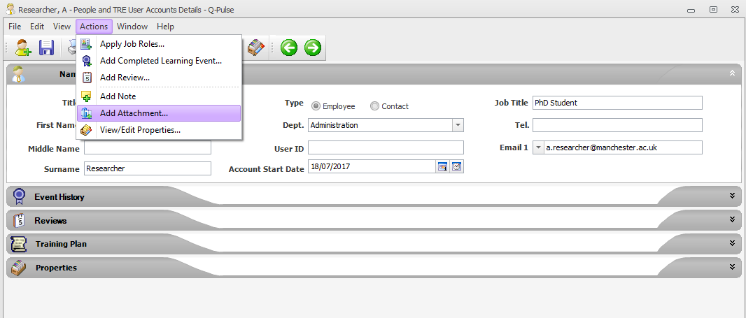

* This displays the ‘Edit Attachment’ dialog.
* Note: this option will not be available if the person record selected is not set within the Q-Pulse reporting structure as being line managed by you.

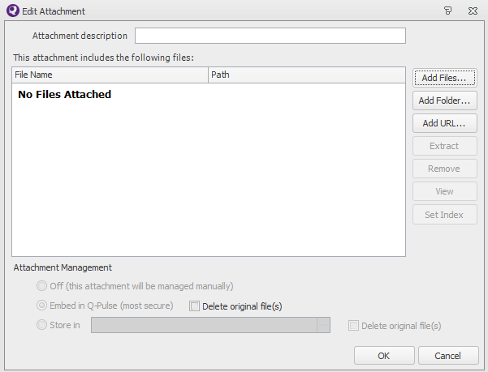

* Click on the  button to display windows explorer where the copy of the completed FORM-004 can be selected.
* Note: the file can be attached as either a Word document (.docx) or a scanned image (.pdf) of the completed form. The file must be closed before it can be attached to Q-Pulse.
* After the file has been selected click on ‘OK’ and save the person record.